**Cisco UCS C220 M5SX Physical build**

Enter servers IP address in browser “<https://10.91.6.3>”  
  
You will be prompted for login details, use the following

admin

password

Change to:

ILOAdmin

IL0Adm1n

Machine generated alternative text:
O 
/10.91 fYindex.ht 
Cisco Integrated Managem... 
ServiceNow 42 Dashboard Device42 vSphere Client 
Cisco Integrated Management Controller 
Cisco 
/ Chassis / Summary 
Server Properties 
Certificate error 
- C220-WZP23280RYJ 
Refresh I Host Power I Launch KVM I Ping I CIMC Reboot I Locator LED I O 
Cisco Integrated Management Controller (Cisco IMC) Information 
Product Name: 
Serial Number: 
PID: 
LJUID: 
BIOS Version: 
Description: 
Asset Tag: 
UCS C220 M5SX 
WZP23280RYJ 
UCSC-C220-M5SX 
3D2A8CF5-4EA9-4702-81EF-A852F7663D23 
C220M5_4.O.4b.OÆ407190256 
Unknown 
Hostname: 
IP Address: 
MAC Address: 
Firmware Version: 
Current Time (UTC): 
Local Time: 
Timezone: 
Server Utilization 
C220-WZP23280RYJ 
Tue Oct 15 2019 
Tue Oct 15 2019 UTC +0000 
UTC 
Chassis Status 
Power State: 
On 
Select Timezone 
Save Changes 
Reset Values 

\*Check firmware version - if its lower than 4.0(4f) then upgrade it.

**Updating Firmware version**

Launch KVM (top right) > Select HTML Based KVM

Click on KVM Console  
  
Select Activate virtual media and browse to the location (Z:\\emeaapprepository\CiscoUCSFirmware\UCS C220 or "Z:\UCS C220 M5\Host Upgrade Utility\ucs-c220m5-huu-4.0.4f.iso"

M5\Host Upgrade Utility) that contains the update file and ok.

Then reboot server and press F6 to get into Boot Menu > Choose DVD (TBC) > Select I agree

Select all the items under components > Select all options under the Storage Drives > press Update and Yes to update the selected components.

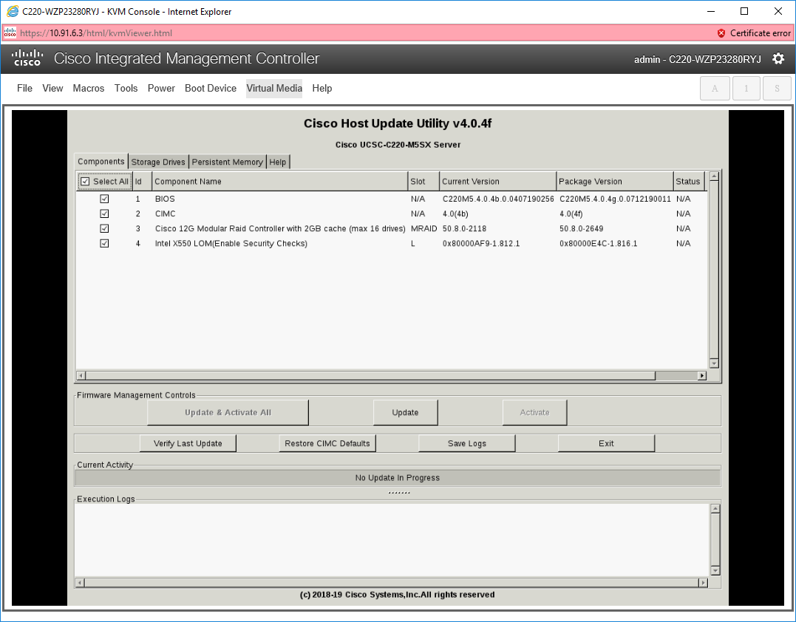  
  
Once complete, select Update  
  
Do you wish to proceed, select YES

Once this stage is complete you will be prompted Update and Activate All

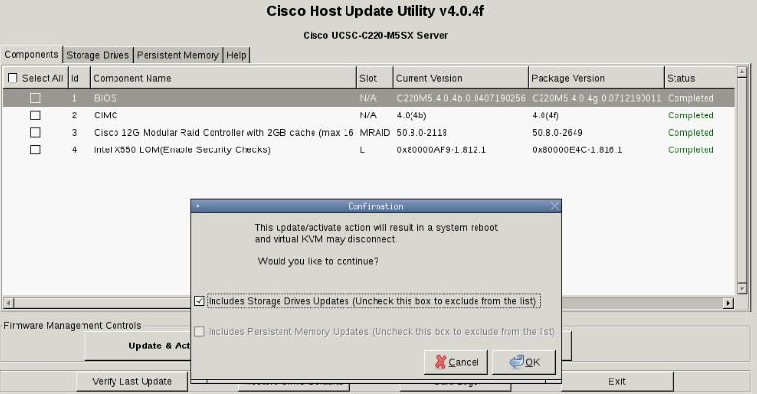  
Do you want to proceed with Firware update, select Yes

**Reverting to the Previous Firmware Version**

There may be instances when you might have to revert to the previously installed firmware version.After installing and activating a later version, you can revert to the previous version using the following options in the CIMC Web UI:

Go to Navigation > Admin > Firmware Management

**RAID Configuration**  
  
The server BIOS includes a configuration utility specific to this controller that you can use to create and

delete RAID volumes, view controller properties, and erase the physical drive contents. Access the utility

by pressing F2 when prompted during server boot. Then navigate to Advanced > Avango MegaRAID > Configure

Machine generated alternative text:
CUO WZP23280RYJ - KVM Console - Internet Explorer 
https://IOSI.63/html/kvmViewer.html 
Cisco Integrated Management Controller 
Cisco 
File View Macros Tools Power Boot Device Virtual Media Help 
Apt io setup Utility 
Certificate error 
admin - C220-WZP23280RYJ 
- copyright (C) 2013 American Megatrends, Inc. 
AVRGCI MegaRAID (Cisco 12G Modular Raid Controller with 2133 cache (max 16 drives) > Co... 
Main Menu 
Help 
PROPERTIES 
Status 
Backplane 
EBU 
Enclosure 
Drives 
Drive Groups 
Virtual Drives 
View Server Prof ile 
ACTIONS 
Conf igure 
Set Factory Defaults 
LIPdate Firmtuare 
Silence Alarm 
BACKGROUND OPERATIONS 
Virtual Drive Operat ions in 
progress 
Drive Operat ions in Progress 
MegaRAID RDVANCED SOFTWARE OPTIONS 
[Opt imal] 
1 
[Yes) 
0 
0 
0 
None 
None 
Number of drives connected to 
this controller. 
+ : Se lect Screen 
tl: Select Item 
Enter: Select 
+/ : Change opt. 
General Help 
F3: Optimized Defaults 
FIO 
: Save a Reset System 
: Exit 
ESC 
: scroll help LIP/DOÅN 
Version 2.20. 1275. Copyright 
201B American Megatrends, 
Inc . 

Create Virtual Drive >

Machine generated alternative text:
CUO WZP23280RYJ - KVM Console - Internet Explorer 
https://IOSI.63/htrnI,'WrnViewer.html 
Cisco Integrated Management Controller 
Cisco 
File View Macros Tools Power Boot Device Virtual Media Help 
(C) 2019 Amer ican Megatrends, 
Certificate error 
admin - C220-WZP23280RYJ 
Inc. 
Apt io Setup Utility 
create Virtual Drive 
One or more J80D drives have been 
detected in the system. only 
Unconf igured Good drives can be 
used in a conf iguration. Please 
select the J8DD drives gou would 
like to convert to Unconf igured 
Good drives from the list belouJ. 
Maxirwrn Allowed unconf igured Good 
Dr ives 
Eligible JBOD Drives for 
Convers ion 
Select JBOD Drives To Make 
Unconf igured Good 
Drive port a 
- SSD, 
SATA, 447.131G8, J80D (Bootable), 
(5128) 
Drive port a 
- SSD, 
SATR, 447. 131G8, J80D, (512B) 
Check All 
Uncheck All 
OK 
Version 2.20.1275. 
- Copyright 
64 
2 
[Disabled] 
[Disabled] 
+ : Select Screen 
u: Select Item 
Enter: select 
Change Opt . 
F 1 : General Help 
FS: optimized Defaults 
FIO 
: Save & Reset System 
Esc: Exit 
KIM: scroll help LIP/DORN 
Copgr ight 
(C) 2013 An-erican Megatrends, 
Inc. 

Enter to select drive and enable, repeat the same process to enable the other drives and OK to commit the changes

Highlight Confirm and press enter > Enable > select Yes to proceed

Select RAID level - enter > select desired RAID level - enter

Machine generated alternative text:
CUO WZP23280RYJ - KVM Console - Internet Explorer 
http5:,','10.91.63/htmI,'kvmViewer.html 
Cisco Integrated Management Controller 
Cisco 
File View Macros Tools Power Boot Device Virtual Media Help 
Aptio Setup utility 
create Virtual Drive 
Certificate error 
admin - C220-WZP23280RYJ 
2013 ican Megatrends, Inc. 
save conf iguration 
select RAID Level 
Secure Virtual Drive 
Unmap Capability 
Select Drives From 
select Drives 
CONFIGURE VIRTUAL DRIVE 
Virtual Drive Name 
Virtual Drive Size 
Virtual Drive Size Unit 
Strip Size 
Read policy 
Hr ite Policy 
1/0 POI icy 
Access Policy 
Drive Cache 
- Copyr ight 
[RAIDO] 
[D led] 
[D isabled] 
[Unconf igured 
PARAMETERS : 
Capac it g] 
Level 
select 
RAIDO 
RAIDI 
RAIDOO 
[unchanged] 
[Def 
Disable Background Initialization 
Default Initialization 
Emulat ion Type 
Save Conf igurat ion 
Version 2.20. 1275. 
selects the desired RAID 
level. The RAID levels that 
can be configured are O, 1, S, 
6 (if supported), 00, 10, SO, 
and 60 (if supported) . 
uses drive striping 
RAID O 
to provide high data 
throughput, especial lg for 
large files in an environment 
that requires no data 
redundancy. 
+ : Screen 
TI.• Select Item 
Enter: Select 
: Change Opt. 
Fl: General Help 
F3: optimized Defaults 
FIO 
: Save 8 Reset System 
Esc: Exit 
Scroll help LIP/DCIÅN 
Copyr ight 
(C) 2013 American Megatrends, 
Inc. 

Move down to **Select drives from** - enter and ensure **Unconfigured Capacity** is selected

Select Drive Groups > Choose Drive Group > Drive Group 0: RAID1 > Select Enable > Apply Changes > OK

Configure Virtual Drive Parameters and select **Virtual Drive Size**:

Select the size of your Virtual disk > Default Initialisation and select Full > Save Configuration

And repeat process for additional virtual drives

\*For file systems

\data

\opt

Select Drives - enter (as shown below) > Choose Unconfigured drives and select each disk and enable > Apply changes - enter

A message will appear that all free space has been used.

Machine generated alternative text:
CUO WZP23280RYJ - KVM Console - Internet Explorer 
https://IOSI.63/htrnI,'WrnViewer.html 
Cisco Integrated Management Controller 
Cisco 
File View Macros Tools Power Boot Device Virtual Media Help 
Aptio SetUP Utility 
select Drives 
Apply Changes 
Select Media Type 
Select Interface Type 
Logical Sector Size 
CHOOSE UNCONFIGURED DRIVES: 
Dr i ve 
port B 
- SSD, 
446.102G8, unconf igured 
SATA, 
Good , 
(512B) 
Dr i ve 
Port 8 
- SSD, 
SATA, 446.102G8, Unconf igured 
Good , 
(512B) 
Check 
All 
Uncheck All 
apply Changes 
Version 2.20. 1275. 
- Copyr ight 
[80th] 
[Both] 
[Enab led] 
[Enab led] 
Certificate error 
admin - C220-WZP23280RYJ 
(C) 2013 ican Megatrends, Inc. 
submits the changes made to 
the entire form. 
+: Select Screen 
TI.• Select Item 
Enter: Select 
: Change Opt. 
Fl: General Help 
F3: optimized Defaults 
FIO 
: Save 8 Reset System 
Esc: Exit 
Scroll help LIP/DCIÅN 
Copyr ight 
(C) 2013 American Megatrends, 
Inc. 

OK - enter > go to Save Configuration - enter

Select confirm and enable - enter > select yes - enter > ok

F10 save and reset

Raid Configuration using the CIMC (GUI)

Virtual Drive:

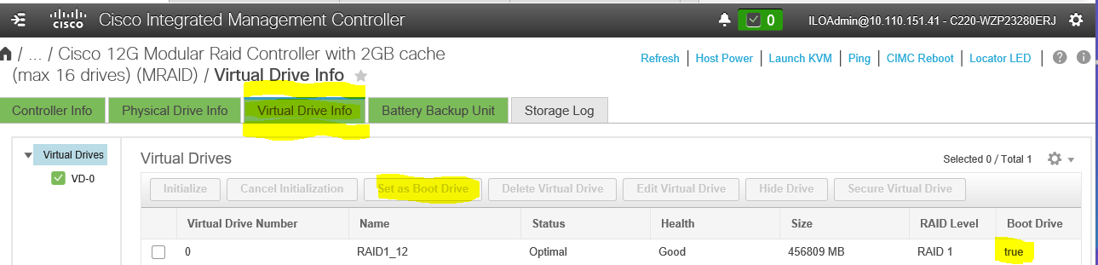Physical Drive:

Select both physical drives and click chevron tab to unconfigure from JBOD

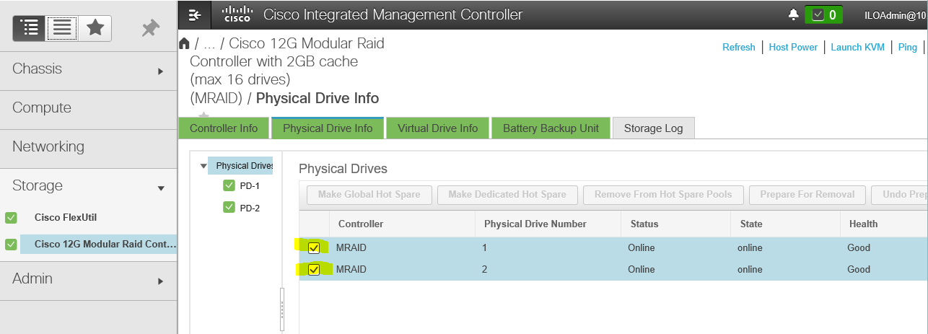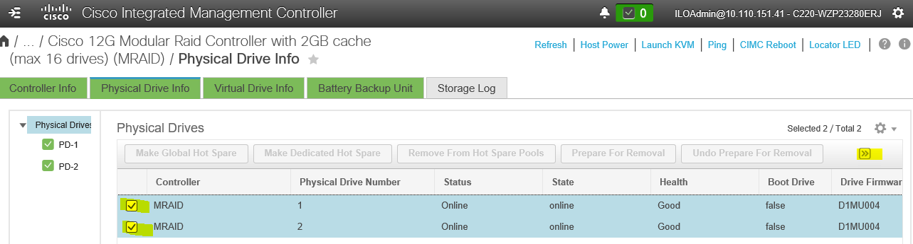Select ”Create Virtual Drive form Unused Physical Drives” (will be RAID1 in next screen)  
  
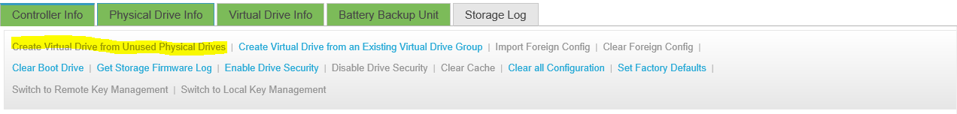

**Linux 7.6 Build**

Launch the KVM from the CIMC console

Select HTML KVM

Select Virtual Media and activate virtual devices

Select virtual Media again and select Map CD\DVD (as shown below)

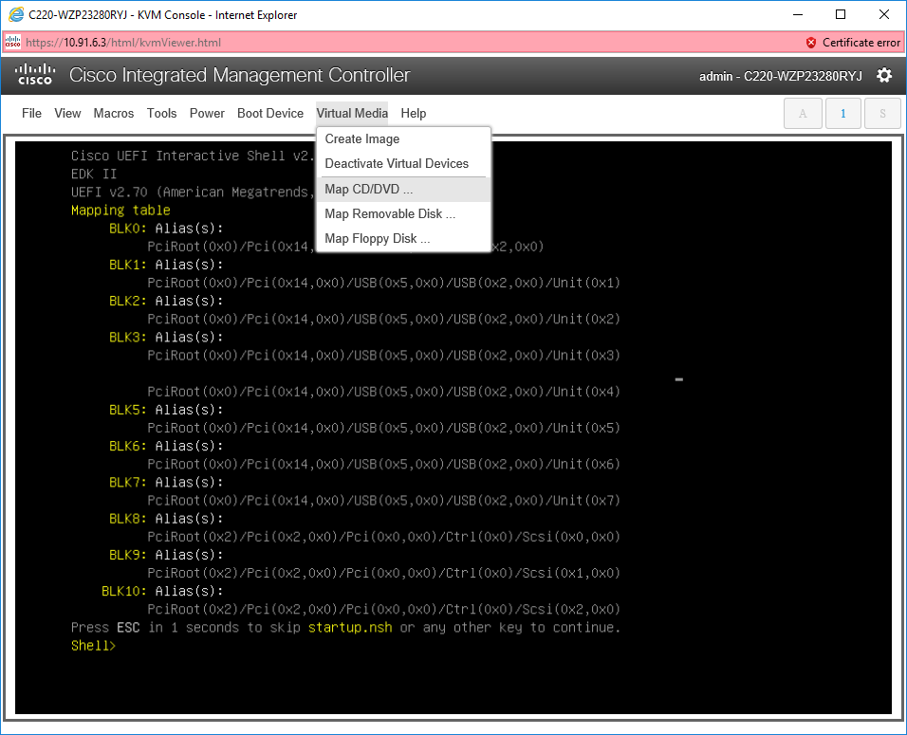

When clicking on Browse, it will display network drives where Full Satellite iso was downloaded to on your PC > open > map drive Select Power and power cycle the server, press F6 to enter the Boot Menu

Select VKVM-Mapped VDVD and enter

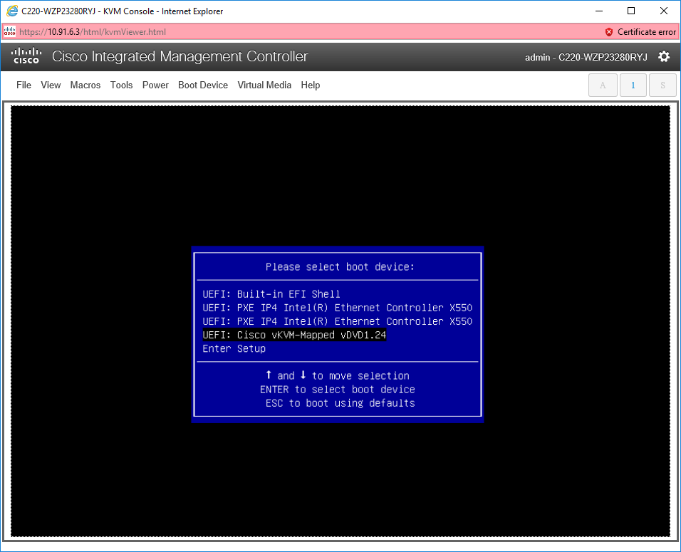

Select Satellite Full ISO build that you have created and placed on your C: drive Press any key to boot from DVD

Once the OS install has completed, from the KVM > select Macros > Static Macro > Select CTRL ALT Del

Set password and login